From Vector Stores to Query Engines

​To generate and store embeddings, LlamaIndex uses the VectorStoreIndex class.
For simple use cases where vectors are generated using a default model and stored in-memory: 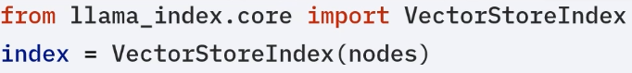

For complex use cases with custom models and persistent storage:
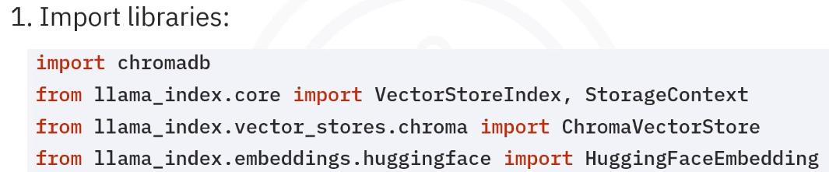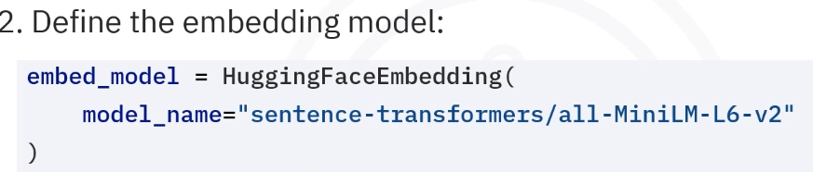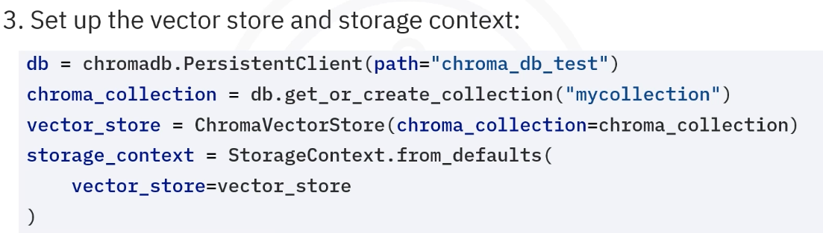
Line 1 – Creates or connects to a local database folder, data is stored on disk at “chroma_db_test”
Line 2 – A collection is basically a table in vector DB, this line means if it exists reuse it and if it doesn’t exist create it.
Line 3 – In order for Llamaindex to talk to Chroma
Line 4 – Creating a storage context, basically telling where and how should llamaindex store data. Here we are telling “Use this Chroma vector store instead of in-memory storage”
https://chatgpt.com/c/WEB:659d19b6-7f43-43e7-87c4-565ff73761ba
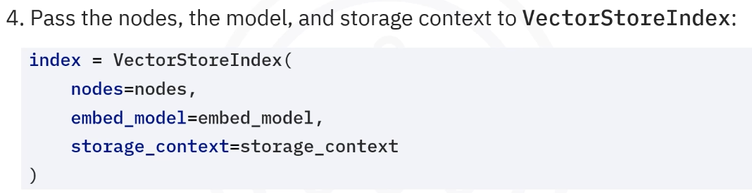

Notice in the simple use case where vectors were generated using default model and stored in-memory. In the instance we were just passing the nodes but here we are also passing the embed model (not default) and the storage context (persistent and not in-memory unlike the simple usecase).
Now that we have the db, lets take a look at the retrieval steps
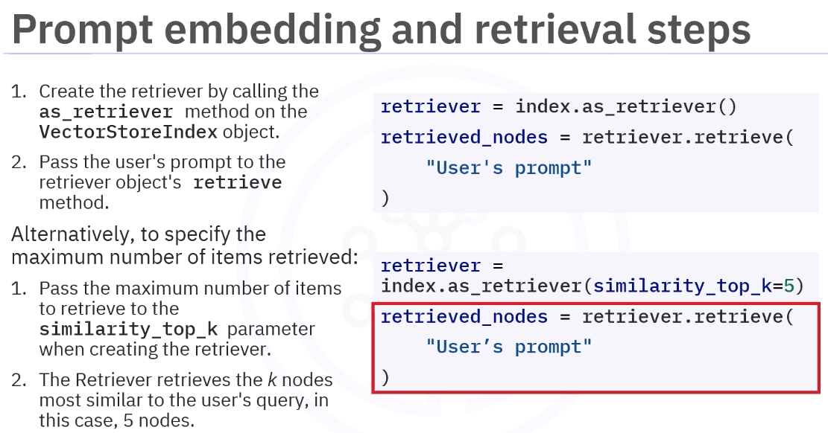

Prompt augmentation, LLM querying and response generation:
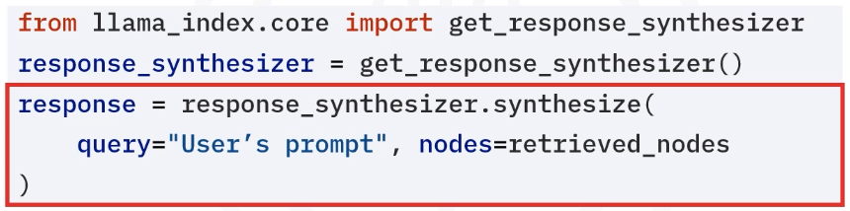

LlamaIndex has the ability to combine the prompt augmentation, ​LLM querying, and response generation RAG steps using a response synthesizer.
​Given a user's prompt and retrieved nodes, the response synthesizer's synthesize method ​generates a response from the LLM. Note that the embedding of the user's prompt, ​prompt augmentation, and the passing of the augmented prompt to the LLM are done in the ​background, and no additional steps have to be taken by the user to perform these steps manually. Its that easy!!

Query Engines take it to the next level and is more easier than using ger_response_synthesizer!!
​LlamaIndex's query engine combines the prompt embedding, ​retrieval, prompt augmentation, LLM querying, and response generation steps, ​eliminating the need to manually retrieve nodes and to pass them to a response synthesizer. ​Given a user's prompt, the query engine's query method generates a response from the LLM. ​Note that the embeddings of the user's prompt, retrieval, prompt augmentation, ​and the passing of the augmented prompt to the LLM are done in the background, ​and no additional steps have to be taken by the user to perform these tasks manually. ​As a result, LlamaIndex's query engines greatly reduce the amount of code that needs to be ​written when building a RAG application
